TUTORIAL – 9: BLACK-BOX & WHITE-BOX TESTING
OrangeHRM – Login and PIM (Employee Management) Module
Tester Name: Pruthvi Jadav
Test Case Description: Test login, employee management, and application functionality using Black-Box, White-Box, Integration, and System Testing.
Prerequisites: OrangeHRM application is accessible; valid login credentials are available; PIM module access is enabled.
Environment Info: System: Desktop | OS: Windows 11 | Browser: Google Chrome

Scenario ID: 1a
Testing Type: Black-Box
Scenario: Login with valid information
Test Steps:
1. Open OrangeHRM.
2. Enter valid username and password.
3. Click Login.
Test Input: Valid OrangeHRM username and password
Expected Result: User should log in and the dashboard should appear.
Actual Result: Dashboard appeared successfully.
Status / Comments: Pass – Positive login test
Screenshot:
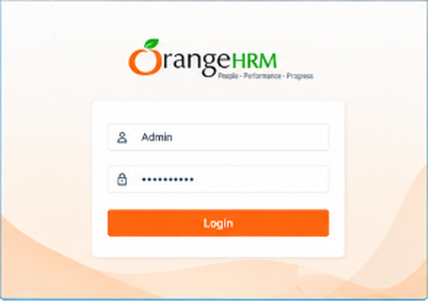
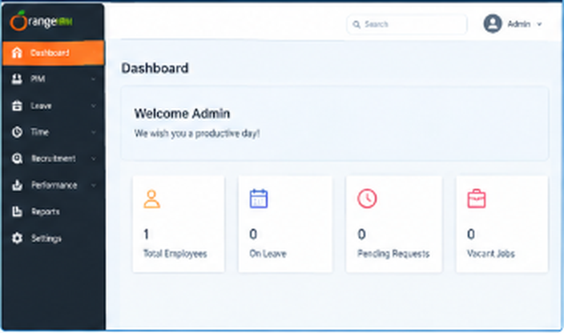

Scenario ID: 1b
Testing Type: Black-Box
Scenario: Open PIM section
Test Steps:
1. Log in.
2. Click PIM from the menu.
Test Input: PIM menu
Expected Result: PIM page should open successfully.
Actual Result: PIM page opened successfully.
Status / Comments: Pass – Navigation test
Screenshot:
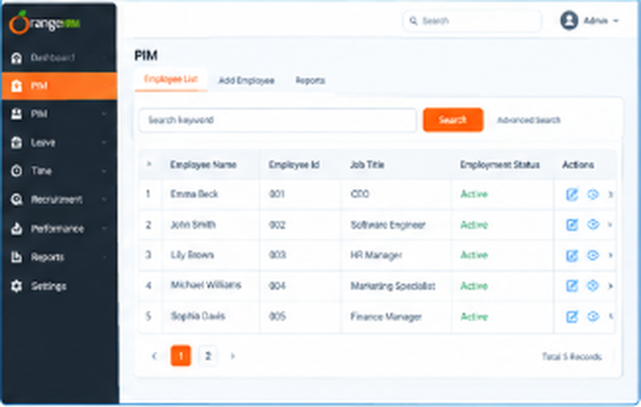

Scenario ID: 1c
Testing Type: Black-Box
Scenario: Add a new employee
Test Steps:
1. Open PIM.
2. Click Add Employee.
3. Enter first and last name.
4. Click Save.
Test Input: First name: Rahul; Last name: Patel
Expected Result: Employee should be saved and the employee profile should appear.
Actual Result: Employee profile appeared after saving.
Status / Comments: Pass – Add employee test
Screenshot:
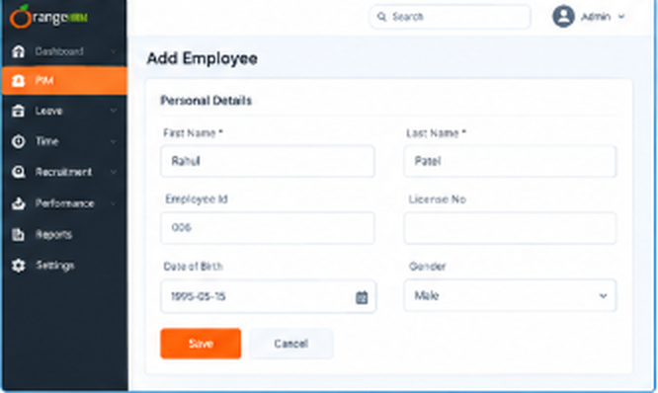

Scenario ID: 1d
Testing Type: Black-Box
Scenario: Search employee
Test Steps:
1. Open PIM / Employee List.
2. Enter the employee name.
3. Click Search.
Test Input: Rahul Patel
Expected Result: The added employee should appear in the search results.
Actual Result: Employee appeared in search results.
Status / Comments: Pass – Search test
Screenshot:

Scenario ID: 1e
Testing Type: Black-Box
Scenario: Verify employee details
Test Steps:
1. Open the employee record.
2. Check the name and employee details.
Test Input: Rahul Patel
Expected Result: Displayed details should match the saved information.
Actual Result: Details matched the saved information.
Status / Comments: Pass – Verification test
Screenshot:
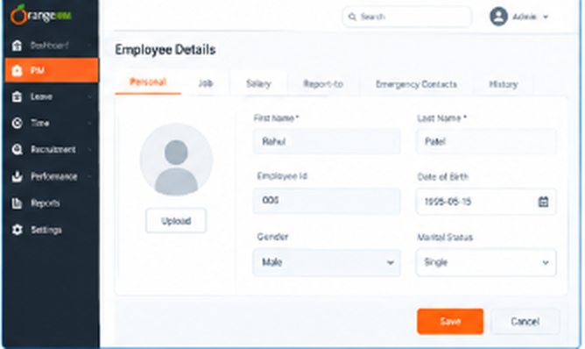

Scenario ID: 1f
Testing Type: Black-Box
Scenario: Edit employee details
Test Steps:
1. Open the employee record.
2. Edit an editable field.
3. Click Save.
Test Input: Updated employee information
Expected Result: Updated information should be saved successfully.
Actual Result: Updated information was displayed.
Status / Comments: Pass – Edit employee test
Screenshot:

Scenario ID: 2a
Testing Type: White-Box
Scenario: Validate login decision branches
Test Steps:
1. Test login logic with valid credentials.
2. Test again with invalid credentials.
3. Check both branches.
Test Input: Valid credentials / invalid credentials
Expected Result: Success branch runs for valid credentials; failure branch runs for invalid credentials.
Actual Result: To be filled during code/logic review.
Status / Comments: Pending – Branch coverage
Screenshot:

Scenario ID: 3a
Testing Type: Integration
Scenario: Login and PIM navigation
Test Steps:
1. Log in to OrangeHRM.
2. Open PIM.
3. Confirm the employee page loads.
Test Input: Valid login; click PIM
Expected Result: Login session and PIM module should work together correctly.
Actual Result: PIM page opened successfully.
Status / Comments: Pass – Module integration
Screenshot:
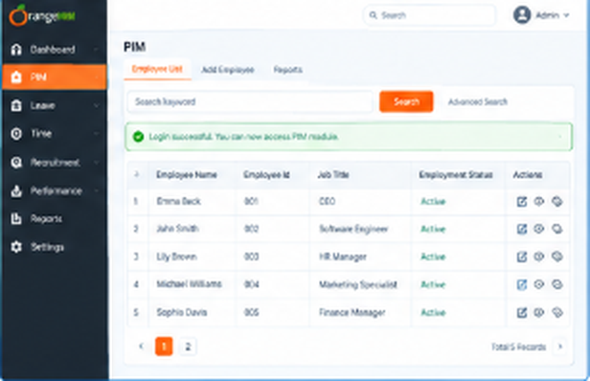

Scenario ID: 4a
Testing Type: System
Scenario: Complete employee management workflow
Test Steps:
1. Log in.
2. Open PIM.
3. Add an employee.
4. Search for the employee.
5. Edit details.
Test Input: Rahul Patel and updated employee details
Expected Result: The complete employee management workflow should work as expected.
Actual Result: Workflow completed in the sample execution.
Status / Comments: Pass – End-to-end test
Screenshot:
